False.

Counterexample:

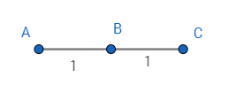

The graph has a longest path (A, B, C).

Assume k=10, then the reweighted graph is

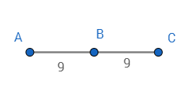

, and has a shortest path (A, B). But (A, B) is not a longest path in the original graph.